Project #2 - Sphere Value Study
Place your name and class number in the upper right side of the paper.
Supplies: You will need one sheet of paper, a pencil, a ruler, 1 stick of graphite, a plastic disposable plate (round template), and a large eraser.
Place a large circle in the center of the paper (the paper should be turned lengthwise horizontally). Use the disposable plate upside down as a template for the circle. Using your ruler draw a straight line from the left side of the page to the right side but do not draw through the circle, and this will represent the edge of a table which would appear to go behind the circle which we call an implied line. Create a cast shadow on the table top on the right hand side of the circle.
Chiaroscuro is an Italian term that means “Light/Dark” and dramatically creates the look of three dimensions out of a two dimensional drawing. To create the illusion of a three dimensional sphere on the table out of the circle you will create a shadow on the sphere on the right hand side and a cast shadow on the table on that side. Using the graphite stick on a flat side begin to darken the cast shadow first. The cast shadow should be the darkest element in the drawing. Then begin darkening the sphere from that side. It is important to show a gradual change from dark to light going towards the left hand side of the sphere. There should be an area on the sphere on the far left which is white. This allows us to imagine the light source is coming from the upper left hand side of the drawing. You may smooth the graphite with a Q-tip or paper towel or your finger creating a smooth texture. Make the change in value so gradual that you do not have lines showing in the shading.
The eraser is useful as a tool to keep your whites clean and to clean off fingerprints in the white areas. Unlike the drawing below, leave all other areas white: the background and the table (except for the cast shadow). Neatness will count as part of your grade.
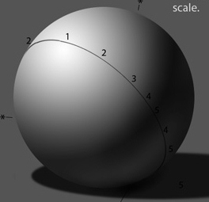
Key ideas and words used in this project: Value, gradation, Chiaroscuro, Illusion of three dimensions in a two dimensional drawing, implied line, texture.

